

Sustainable development goals of the United nations

NO HUNGER



11 november 2017

Annelies BAkker - student number 154652

Environmental Science by C. Mettes & T. Sevold

Table of content

Sustainable development goals (SDG) of the United nations. 2

Target 2 3

Target 3 5

Aruba 6

Key Figures 9

(Statistics, 2017) 9

Bibliography 10

## Sustainable development goals (SDG) of the United nations.

The United Nations has aligned 17 goals in order to better the world on several essential aspects of life and the well-being of the world population. The designated goal, is number two of the list of the sustainable development goals which is called “No Hunger”. Which entails: End hunger, achieve food security and improved nutrition and promote sustainable agriculture.

The definition of Stunting is prevention from growing or developing properly.

According to the United Nations the following information is known and I will quote due to the factual information stated by the United nations: “In 2016, an estimated 155 million children under 5 years of age were stunted (too short for their age, a result of chronic malnutrition). Globally, the stunting rate fell from 33 per cent in 2000 to 23 per cent in 2016. Southern Asia and sub-Saharan Africa accounted for three quarters of all stunted children that year.

In 2016, an estimated 52 million children under 5 years of age worldwide suffered from wasting (with a low weight for their height, usually the result of an acute and significant food shortage and/or disease). The global wasting rate in 2016 was 7.7 per cent, with the highest rate (15.4 per cent) in Southern Asia. At the other end of the spectrum, overweight and obesity affected 41 million children under 5 years of age worldwide (6 per cent) in 2016.

Ending hunger demands sustainable food production systems and resilient agricultural practices. One aspect of that effort is maintaining the genetic diversity of plants and animals, which is crucial for agriculture and food production. In 2016, 4.7 million samples of seeds and other plant genetic material for food and agriculture were preserved in 602 gene banks throughout 82 countries and 14 regional and international centers — a 2 per cent increase since 2014. Animal genetic material has been cryo-conserved, but only for 15 per cent of national breed populations, according to information obtained from 128 countries. The stored genetic material is sufficient to reconstitute only 7 per cent of national breed populations should they become extinct. As of February 2017, 20 per cent of local breeds were classified as at risk.

Increased investments are needed to enhance capacity for agricultural productivity. However, the global agriculture orientation index — defined as agriculture’s share of government expenditure divided by the sector’s share of gross domestic product (GDP) — fell from 0.38 in 2001 to 0.24 in 2013 and to 0.21 in 2015.

The share of sector-allocable aid allocated to agriculture from member countries of the Development Assistance Committee of the Organization for Economic Cooperation and Development (OECD) fell from nearly 20 per cent in the mid-1980s to 7 per cent in the late 1990s, where it remained through 2015. The decline reflects a shift away from aid for financing infrastructure and production towards a greater focus on social sectors.

In 2016, 21 countries experienced high or moderately high domestic prices, relative to their historic levels, for one or more staple cereal food commodities. Thirteen of those countries were in sub-Saharan Africa. The main causes of high prices were declines in domestic output, currency depreciation and insecurity. Localized increases in fuel prices also drove food prices higher.

Some progress has been made in preventing distortions in world agricultural markets. The global agricultural export subsidies were reduced by 94 per cent from 2000 to 2014. In December 2015, members of the World Trade Organization adopted a ministerial decision on eliminating export subsidies for agricultural products and restraining export measures that have a similar effect.(Report of the Secretary-General, "Progress towards the Sustainable Development Goals", [E/2017/66](http://www.un.org/ga/search/view_doc.asp?symbol=E/2017/66&Lang=E). 2017) (UN, Sustainable development goal 2, 2017).

The fight against hunger has progressed over the past 15 years. Globally, the prevalence of hunger has declined, from 15 per cent according to figures for 2000 to 2002, to 11 per cent according to figures for 2014 to 2016. However, more than 790 million people worldwide still lack regular access to adequate amounts of dietary energy. If current trends continue, the zero hunger target will be largely missed by 2030”. (UN, Sustainable development goal 2, 2017)

My elected targets of the goal of “No hunger” are 2 and 3 which are,

## Target 2

By 2030, end all forms of malnutrition, including achieving, by 2025, the internationally agreed targets on stunting and wasting in children under 5 years of age, and address the nutritional needs of adolescent girls, pregnant and lactating women and older persons.

* + 1. **Prevalence of stunting (height for age <-2 standard deviation from the median of the World Health Organization (WHO) Child Growth Standards) among children under 5 years of age**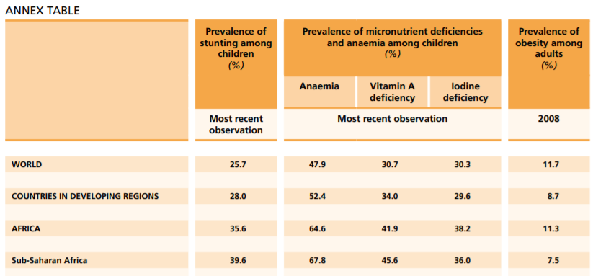

  






Annex table from (Unicef, 2012)

* + 1. **Prevalence of malnutrition  (underweight or overweight):**

“Stunting • Globally, an estimated 165 million children under-five years of age, or 26%, were stunted (i.e, height-for-age below –2 SD) in 2011 — a 35% decrease from an estimated 253 million in 1990. • High prevalence levels of stunting among children under-five years of age in Africa (36% in 2011) and Asia (27% in 2011) remain a public health problem, one which often goes unrecognized. • More than 90% of the world’s stunted children live in Africa and Asia.

Underweight • Globally, an estimated 101 million children under-five years of age, or 16%, were underweight (i.e., weight-for-age below –2SD) in 2011 — a 36% decrease from an estimated 159 million in 1990. • Although the prevalence’s of stunting and underweight among children under-five years of age worldwide have decreased since 1990, overall progress is insufficient and millions of children remain at risk.

Wasting • Globally, an estimated 52 million children under-five years of age, or 8%, were wasted (i.e., weight-for-height below –2SD) in 2011 — a 11% decrease from an estimated 58 million in 1990. • Seventy percent of the world’s wasted children live in Asia, most in South-Central Asia. These children are at substantial increased risk of severe acute malnutrition and death.

Overweight • Globally, an estimated 43 million children under-five years of age, or 7%, were overweight (i.e., weight-for-height above +2SD) in 2011 — a 54% increase from an estimated 28 million in 1990. • Increasing trends in child overweight have been noted in most world regions, not only developed countries, where prevalence is highest (15% in 2011). In Africa, the estimated prevalence under-five overweight increased from 4% in 1990 to 7% in 2011. The prevalence of overweight was lower in Asia (5% in 2011) than in Africa, but the number of affected children was higher in Asia (17 million) than in Africa (12 million). • Proper nutrition contributes significantly to declines in under-five mortality rates. Improving nutritional status is essential for achieving the Millennium Development Goals (MDGs)”

(UN, WHO, Unicef, 2012)

## Target 3

By 2030, double the agricultural productivity and incomes of small-scale food producers, in particular women, indigenous peoples, family farmers, pastoralists and fishers, including through secure and equal access to land, other productive resources and inputs, knowledge, financial services, markets and opportunities for value addition and non-farm employment.

**2.3.1 Volume of production per labor unit by classes of farming/pastoral/forestry enterprise size**

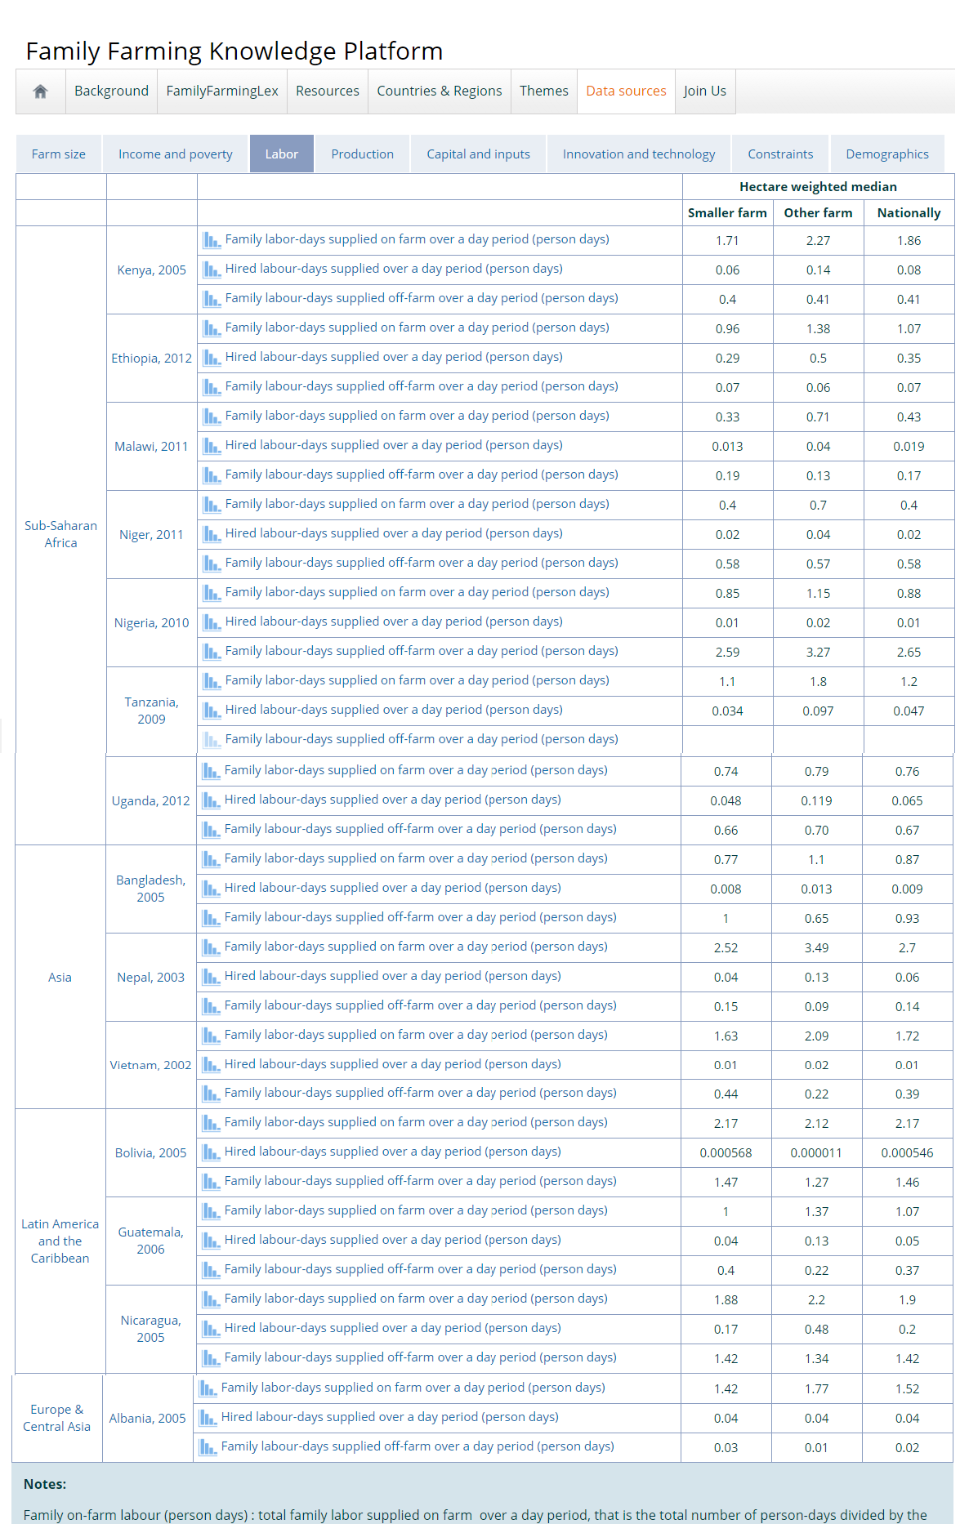

(FAO, 2017)

**2.3.2 Average income of small-scale food producers, by sex and indigenous status.**

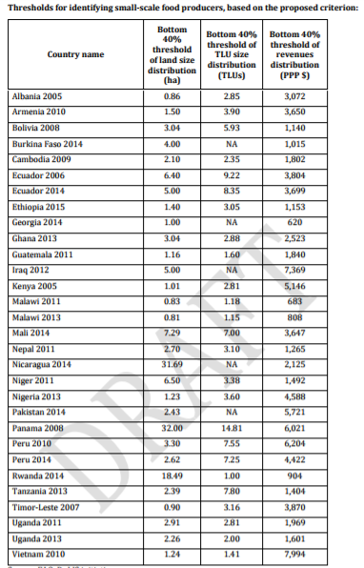

(Office of the Chief Statistician and Statistics Division, FAO , 2017)

## Aruba

After research into what Aruba is doing in efforts of this cause, the direct information was very limited, as on most links it was noted the following and I quote:

“We, the National SDG Commission, are hard at work connecting with NGOs across the island to put their information on this page. Please check regularly for updated information and new NGOs to discover.

If you are an NGO and we have not had contact yet, please get in touch with us [here](http://sdgaruba.com/contact/). Look forward to hearing from you

Although it is stated that Ngo’s as well as the private sector are doing something for this cause. “

The SDG’s, I might believe that there are people living in some type of poverty in Aruba, for which school meals might be a good way to toggle stunting, if in existence in Aruba.

This goal could relate to waste management in Aruba yet no correlating data could be found. It is known that there are several companies that work for waste management solutions in Aruba. Such as Atco, Ecotech, Ecogas, and a few more. After research into the interviews about the waste management companies in Aruba it became clear that most waste is shipped from the island. Yet one company called Carentra actually picks up tires from the islands dump, and recycles 100% of them, to turn them in to different types of fuel such as diesel fuel. Unfortunately this is not done with plastic nor paper.

Here are some statistics that are known about Aruba by the CBS and have some correlation with the designated SDG’s. (UN, World Statictics pocketbook, 2017)

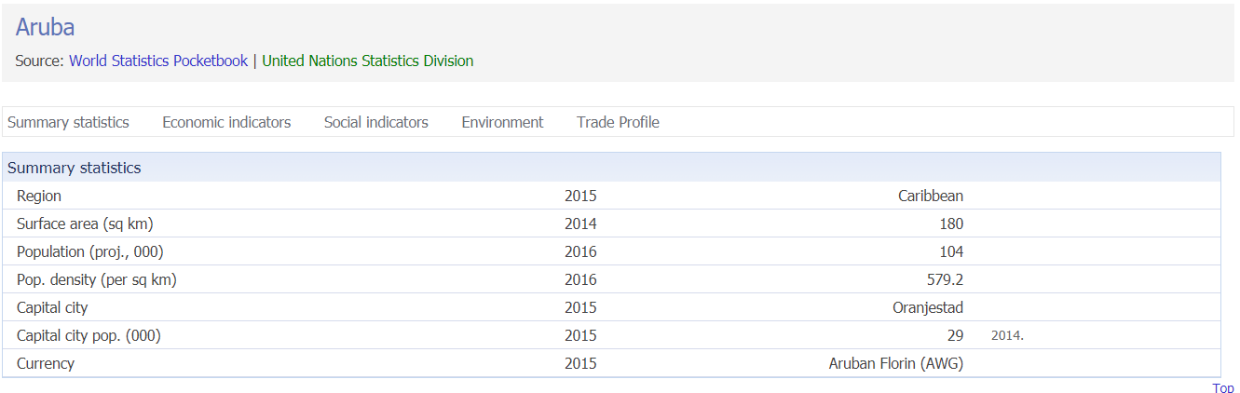

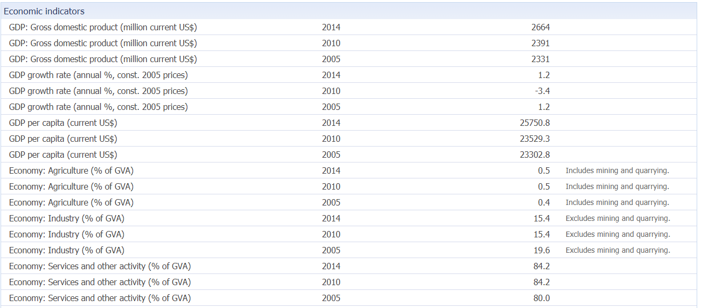

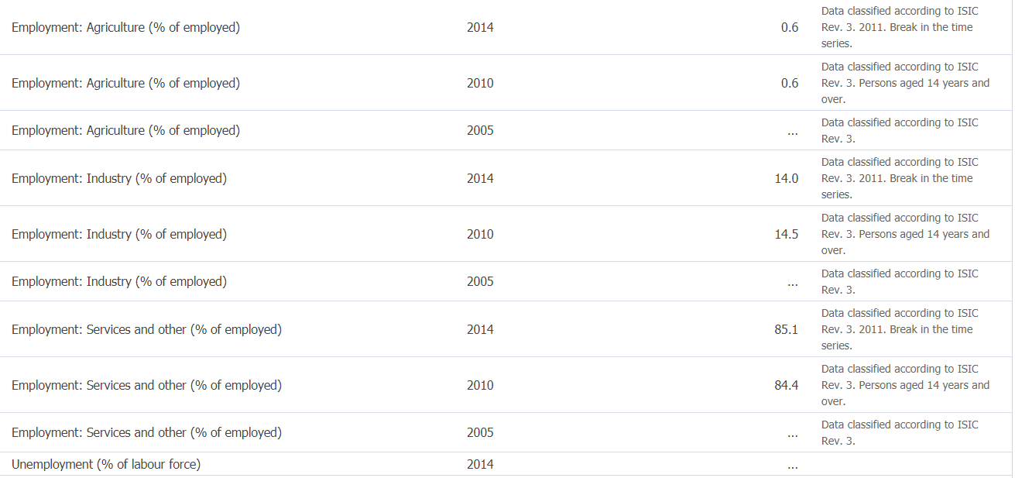

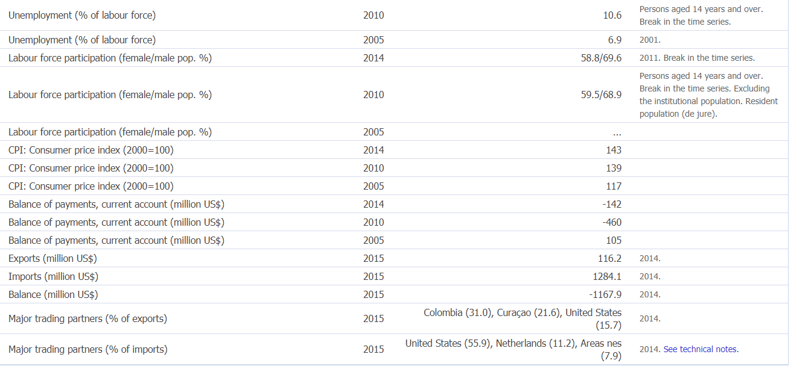

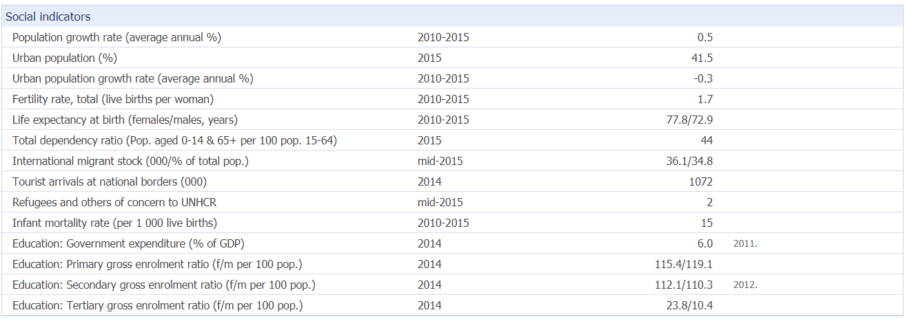

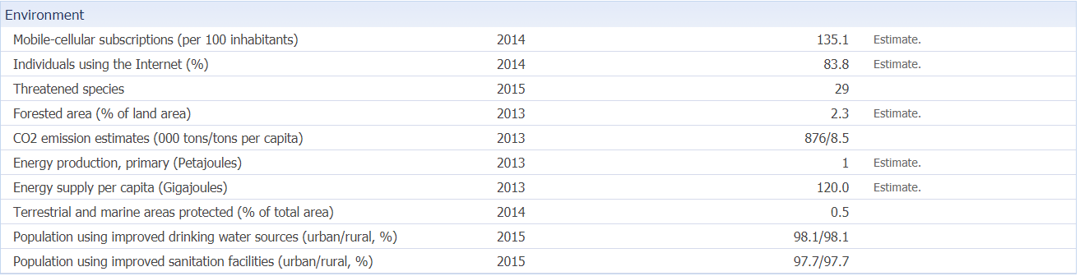

Some other key figures that are known about Aruba are the following:

### Key Figures

|  |  |  |
| --- | --- | --- |
| **Description** | **Period** | **Value** |
| **Inflation** | | |
| Monthly change | September-17 | 0.1% |
| End of period | September-17 | -0.8% |
| Period average | September-17 | -0.4% |
| **GDP of Aruba** | 2011 | Afl. 4,626 Mln |
| **Airport Commercial Landings** | Dec YTD 2014 | 14,509 (-7.6%) |
| **Airport Arrivals Foreigners** | Dec YTD 2014 | 1,100,334 (+10.7%) |
| **Government Tax Revenue** | Dec YTD 2014 | 1,051,221 |
| **Total population** | 2nd qrt-2017 | 110,882 |
| **Change in population** | | |
| Births | 2nd qrt-2017 | 273 |
| Deaths | 2nd qrt-2017 | 179 |
| Immigration | 2nd qrt-2017 | 671 |
| Emigration | 2nd qrt-2017 | 630 |
| **Total imports** | 2nd qrt-17 | 509.8 Mln |
| **Total exports** | 2nd qrt-17 | 41.6 Mln |
| **Rooms(hotels)** | | |
| Occupancy rate | Dec YTD 2013 | 77.5% (-1.9%) |
| Average daily rate | Dec YTD 2013 | US$ 208.20 (+6.7%) |
| Revenue per available room | Dec YTD 2013 | US$ 98.60 (+7.7%) |
| version 26 October 2017 | | |

### (Statistics, 2017)

# Bibliography

FAO. (2017). *Family Farming Knowledge Platform.* Retrieved from http://www.fao.org/family-farming/data-sources/dataportrait/labor/en/

Office of the Chief Statistician and Statistics Division, FAO . (2017). *Proposed International Definition of Small-Scale Food Producers For Monitoring SDGs 2.3.1 and 2.3.21.* Retrieved from http://www.fao.org/3/a-bt612e.pdf

Statistics, C. B. (2017). *Key figures Aruba.* Retrieved from http://cbs.aw/wp/index.php/2015/09/01/statistical-act/

UN. (2017). *Sustainable development goal 2.* United Nations. Retrieved from https://sustainabledevelopment.un.org/sdg2

UN. (2017). World Statictics pocketbook. *United Nations Statitics Divison*. Retrieved from http://data.un.org/CountryProfile.aspx?crName=Aruba#Social

UN, WHO, Unicef. (2012). *Levels & trends in child malnutrition.* Retrieved from http://www.who.int/nutgrowthdb/jme_unicef_who_wb.pdf

Unicef, W. W. (2012). *Prevalence of stunting amongst children.* Retrieved from http://www.fao.org/docrep/018/i3300e/i3300e07.pdf

United Nations. (2017). *Goal 2: End hunger, achieve food security and improved nutrition and promote sustainable agriculture.* Retrieved from http://www.un.org/sustainabledevelopment/hunger/